

Waste2Goods: IoT-Enabled Recycling Port with Task-Based Recyclable Collection and Points-to-Goods Redemption System

____________________________________

In Partial Fulfillment Of The
Academic Requirements for the Subject
CAPSTONE AND RESEARCH 1
______________________________________

Presented by:
Ryota Sheandrew Yñigo J. Iwamoto
Daniella Marie C. Bello
Jayquio M. Lagrama

Presented to:
RYAN N. BILLERA
Adviser

TABLE OF CONTENTS
1. INTRODUCTION 1
1.1 Project Context 1
1.2 Background of the Study 3
1.3 Purpose and Description 3
1.4 Objectives 4
1.4.1 General Objective 4
1.4.2 Specific Objectives 4
1.5 Scope and Limitations 4
2. REVIEW OF RELATED LITERATURE AND STUDY AND SYSTEMS 5
2.1 Related Literature 5
2.2 Related Systems 6
3. TECHNICAL BACKGROUND 8
3.1 Development Tools 8
3.1.1 Flutter 8
3.1.2 Firebase 8
3.1.3 Visual Studio Code 8
3.1.4 Arduino IDE 8
3.1.6 Figma 8
3.1.7 FOMO (Faster Objects, More Objects) 9
3.2 Hardware Components 9
3.2.1 ESP32 Microcontroller 9
3.2.2 Load Cell Sensor 9
3.2.3 HX711 Load Cell Amplifier 9
3.2.4 QR Code Scanner 9
3.2.5 Servo Motor 10
3.2.6 LCD Display 10
3.2.7 Wi-Fi Communication Module 10
3.2.8 ESP32-CAM Module (OV2640 Camera) 10
3.3 System Components 10
3.3.1 Mobile Application 10
3.3.2 IoT Recycling Kiosk 11
3.3.3 Administrative Dashboard 11
3.3.4 Cloud Database 11
4. METHODOLOGY / SYSTEM DESIGN 12
4.1 Research Design 12
4.2 Data Gathering Procedure 12
4.2.1 Sampling Technique 13
4.3 Software Development Methodology 13
4.4 Requirements Analysis 14
4.4.1 Functional Requirements 14
4.4.2 Non-Functional Requirements 15
4.5 System Design 16
4.5.1 Conceptual Framework 16
4.5.2 Data Flow Diagram of the Proposed System 17
4.5.3 Data Flow Diagram 17
4.4.5 System Architecture 18
4.6 Development 19
4.7 System Testing and Validation 19
4.7.1 Testing Strategy 20
4.8 Deployment and Monitoring Plan 20
4.9 Ethical Considerations 20
5. REFERENCES 21

Waste2Goods: IoT-Enabled Recycling Port with Task-Based Recyclable Collection and Points-to-Goods Redemption System
Ryota Sheandrew Yñigo Iwamoto
Jose Maria College Foundation Inc.
ryota.iwamoto@jmc.edu.ph
Daniella Marie C. Bello
Jose Maria College Foundation Inc.
daniella.bello@jmc.edu.ph

Jayquio M. Lagrama
Jose Maria College Foundation Inc.
jayquio.lagrama@jmc.edu.ph

1. INTRODUCTION
Keywords
Internet of Things (IoT), Smart Waste Management, Recyclable Waste Collection, Gamification, Automated Reward System, QR Code Authentication, Cloud Database, Recycling Kiosk

1.1 Project Context
Solid waste management remains one of the persistent environmental concerns affecting many communities in the Philippines. Despite the implementation of national and local waste management programs, improper disposal of recyclable materials continues to contribute to environmental degradation and the inefficient utilization of recyclable resources. Although recycling initiatives have been established by local government units and private organizations, community participation remains inconsistent due to limited awareness, inadequate motivation, and the continued reliance on manual recycling procedures.
Traditional recyclable waste collection commonly depends on manual weighing, handwritten transaction records, and paper-based monitoring. These practices may lead to inaccurate data recording, delayed transaction processing, limited monitoring of recyclable waste collections, and reduced operational efficiency. Furthermore, the absence of an automated and transparent reward mechanism may discourage continuous public participation in recycling activities.
An interview conducted with representatives from the City Environment and Natural Resources Office (CENRO) further identified operational concerns related to recyclable waste management. According to the office, proper waste segregation must begin at the household level, where biodegradable, recyclable, residual, and hazardous wastes should be separated before collection. CENRO also emphasized the implementation of the "No Segregation, No Collection" policy, which discourages improper waste disposal and promotes compliance with Republic Act No. 9003 or the Ecological Solid Waste Management Act of 2000. During the interview, it was explained that recyclable materials collected from communities are transported to the Materials Recovery Facility (MRF), where the recyclable waste are sorted before being delivered to accredited recycling partners, while residual wastes are transferred to sanitary landfills. These existing practices demonstrate the continued reliance on manual waste handling, monitoring, and recycling processes, indicating the need for technology-assisted solutions that encourage proper waste segregation and improve recyclable waste collection.
Recent advancements in the Internet of Things (IoT) have enabled the automation of data collection, monitoring, and communication among interconnected devices. Likewise, gamification has become an effective strategy for encouraging user engagement by integrating rewards, achievements, and goal-oriented activities into routine tasks. The integration of these technologies presents an opportunity to improve recyclable waste collection while motivating individuals to participate consistently in environmental sustainability initiatives.
To further determine the necessity of the proposed system, a pre-implementation survey was conducted among the identified target respondents. The findings revealed that 77.59% of the respondents believed that an IoT-based recycling management system would be beneficial, 53.45% indicated that they were very willing to adopt a digital recycling platform, and 51.72% considered the implementation of such a system to be very urgent. These findings indicate a positive level of acceptance toward an automated recyclable waste collection and reward management system.
Considering the existing challenges identified through the review of current recyclable waste management practices, the consultation with CENRO, and the results of the pre-implementation survey, this study proposes Waste2Goods: An Internet of Things (IoT)-Based Recyclable Waste Collection and Points-to-Goods Redemption System. The proposed system aims to automate recyclable waste collection, improve transaction management, and encourage community participation through a transparent digital reward mechanism.
Based on the review of existing recyclable waste management practices, the consultation conducted with representatives from the City Environment and Natural Resources Office (CENRO) and barangay officials, and the results of the pre-implementation survey, the study identified the following concerns: (1) Existing recyclable waste collection and transaction recording remain largely manual, resulting in inefficient monitoring, delayed processing, and limited record management. (2) Current waste management practices rely heavily on proper waste segregation by residents; however, inconsistent participation and compliance continue to reduce the effectiveness of recyclable waste collection programs. (3) Existing recycling initiatives lack an automated and transparent reward mechanism capable of encouraging continuous community participation in recyclable waste collection. (4) Current recyclable waste management practices provide limited real-time monitoring, reporting, and centralized management of recycling transactions for administrators and partner organizations. (5) There is a need for an integrated Internet of Things (IoT)-based recyclable waste collection and points-to-goods redemption system that automates recyclable waste collection, improves monitoring, and promotes sustainable community participation. These identified concerns served as the basis for the development of the proposed Waste2Goods system and the formulation of the study objectives.

1.2 Background of the Study
The proposed Waste2Goods system is intended for communities, educational institutions, and organizations that implement recyclable waste collection and environmental sustainability programs. The study focuses on recyclable materials, particularly plastic bottles which are among the most commonly generated recyclable wastes in communities.
Existing recyclable waste collection activities generally involve manual recording, manual weighing, and limited monitoring of recycling transactions. These operational practices often require additional administrative effort and may affect the accuracy and efficiency of transaction management. In addition, conventional recycling programs provide limited incentives that encourage long-term participation among community members.
The integration of Internet of Things (IoT) technology into recyclable waste collection offers opportunities to automate transaction recording, improve monitoring, and provide real-time access to recycling information. Through the implementation of an automated points-to-goods redemption mechanism, the proposed system seeks to increase public participation while promoting responsible recyclable waste disposal and environmental sustainability.
Considering the existing challenges identified through the review of current recyclable waste management practices, the consultation with CENRO, and the results of the pre-implementation survey, this study proposes Waste2Goods: An Internet of Things (IoT)-Based Recyclable Waste Collection and Points-to-Goods Redemption System. The proposed system aims to automate recyclable waste collection, improve transaction management, and encourage community participation through a transparent digital reward mechanism.

1.3 Purpose and Description
This study proposes Waste2Goods: An Internet of Things (IoT)-Based Recyclable Waste Collection and Points-to-Goods Redemption System, an integrated recycling platform designed to automate recyclable waste collection and encourage community participation through an incentive-based reward mechanism.
The proposed system consists of an IoT-enabled recycling kiosk, a mobile application, and a web-based administrative dashboard. The recycling kiosk utilizes an ESP32 microcontroller, load cell sensor, HX711 amplifier, QR code scanner, servo motor, and LCD display to automate user authentication, recyclable waste weighing, transaction validation, and reward point computation. Recycling transaction data are transmitted to a centralized cloud database to enable real-time synchronization among all system components.
The mobile application allows registered users to access personal accounts, monitor accumulated reward points, review recycling transaction history, participate in recycling-related activities, and redeem available rewards. Meanwhile, the administrative dashboard enables authorized personnel to monitor recycling activities, manage user accounts, administer reward inventories, verify redemption requests, and generate operational reports.
Through the integration of IoT technology, cloud computing, and digital reward management, the proposed system is expected to improve the efficiency, accuracy, and transparency of recyclable waste collection while encouraging greater community participation in recycling initiatives.
The proposed Waste2Goods system is intended for students, community members, barangay administrators, and system administrators. These users will utilize the system to facilitate recyclable waste collection, monitor recycling activities, manage reward redemption, and support sustainable waste management initiatives.

1.4 Objectives

1.4.1 General Objective
The general objective of this study is to design and develop an Internet of Things (IoT)-based recyclable waste collection and points-to-goods redemption system that automates recyclable waste collection, improves transaction management, and encourages community participation through a digital reward mechanism.

1.4.2 Specific Objectives
Specifically, this study aims to:
- To design an IoT recycling kiosk featuring QR authentication, load-cell weighing, and automated transaction logging.
- To develop a mobile app for user registration, points tracking, transaction history, and rewards redemption.
- To develop a web admin dashboard to monitor waste collection, manage accounts and rewards, and generate reports.
- To integrate cloud services for real-time data synchronization across the kiosk, app, and dashboard.
- To promote community recycling through a transparent, incentive-based rewards system.

1.5 Scope and Limitations
Scope:
This study focuses on the design, development, and evaluation of Waste2Goods, an Internet of Things (IoT)-based recyclable waste collection and points-to-goods redemption system. The proposed system accepts selected recyclable materials, specifically plastic bottles.
The system utilizes an IoT-enabled recycling kiosk equipped with an ESP32 microcontroller, QR code authentication, load cell sensor, HX711 amplifier, servo motor, and LCD display to automate recyclable waste collection and reward point computation. Recycling transaction records are synchronized with a centralized cloud database and can be accessed through a mobile application and a web-based administrative dashboard.
The mobile application enables registered users to monitor recycling activities, review accumulated reward points, access transaction history, accomplish assigned recycling tasks, and redeem available rewards. The administrative dashboard allows authorized personnel to monitor recycling transactions, manage user accounts and reward inventories, and generate collection reports.
The developed system will be evaluated based on the software quality characteristics defined in the ISO/IEC 25010 Software Quality Model, including functional suitability, usability, reliability, performance efficiency, security, maintainability, compatibility, and portability.
The proposed system is designed for registered students and community members who will deposit recyclable plastic bottles using the IoT recycling kiosk. It also supports barangay administrators and system administrators who are responsible for monitoring transactions, managing rewards, and generating reports.
Limitations:
The proposed system is limited to the collection of plastic bottles and does not support biodegradable waste, hazardous waste, electronic waste, glass materials, or other non-recyclable waste categories.
The system requires a stable electrical power supply and internet connectivity to synchronize recycling transactions among the IoT recycling kiosk, cloud database, mobile application, and administrative dashboard. Temporary network interruptions may delay data synchronization until connectivity is restored.
The availability of redeemable rewards depends on participating partner organizations or establishments. Furthermore, the study is limited to the design, development, and evaluation of the proposed system and does not include large-scale community deployment or long-term environmental impact assessment.

2. REVIEW OF RELATED LITERATURE AND STUDY AND SYSTEMS

2.1 Related Literature
2.1.1 Philippine Development Plan 2023-2028 (2025)
Presents an overview of how the structuring of SWM plans within the Philippines occurs with the country being faced with major infrastructure barriers. At the national level, it has been noted that decentralized sorting is preferred since there are cost barriers in centralizing waste management.
In this regard, it makes sense to use Waste2Goods because of its decentralization nature.
2.1.2 Environmental Awareness of Junior High School Students (2025)
Local studies in densely populated barangays reveal that the main reasons for failure of any environmental program implemented locally include insufficient personal motivation, network instability, and irregular sorting of domestic waste. Although the community demonstrates an acceptable understanding of environmental problems, the act of separating waste is significantly undermined without continuous tangible motivation.
The present study reveals that despite high awareness of the issue, there is no tangible motivation for actual segregation practices. The Waste2Goods solution provides a tangible motivational mechanism through the introduction of an immediate points-to-goods reward system at the moment of waste disposal. Moreover, the hardware structure allows for data processing on a localized level and addresses the problem of network instability.
2.1.3 The Emerging Technologies of Digital Payments and Associated Challenges (2022)
Current local engineering developments involve using IoT systems in LPWAN, which is specifically designed to address problems such as localized power outages, unreliable cell phone services, and digital trust issues. The latter issues tend to hinder poor people's uptake of modern payment or credit mechanisms.
The above literature discusses some technical field issues that need to be tackled by decentralized innovations. With the technical issues sorted out locally, the port will have reliable data management and community engagement in the long run.
2.1.4 Mandaluyong Barangay Exchanges Recyclable Trash for Food (2024)
According to various reports, only those initiatives taken by the environment will be considered sustainable if the organizational initiatives of the locality are pursued with the goal of attaining definite objectives.
In various community projects, people tend to segregate the recyclable materials if they get some tangible benefit in return. This report clearly brings out the importance of the need to attach utility with recycling.
2.1.5 Department of Science and Technology Tech Compliance Framework (2021)
Local frameworks of technology compliance in the advanced use of technology in industry in the Philippines guarantees the accuracy of automated transaction logs.
The literature confirms the importance of incorporating an automated system for monitoring and ensuring the transparency of transaction logs within the barangay system.

2.2 Related Systems
2.2.1 IoT-Based Intelligent Waste Management System (2023)
The research by Ahmed et al. (2023) created an IoT-based intelligent waste management system, which included the use of sensors, cloud computing, and monitoring techniques, thereby increasing the efficiency of waste collection and reducing any manual intervention. The research concluded that IoT monitoring helps in ensuring efficiency and accuracy in waste collection.
From the above-mentioned literature, it can be observed that IoT technologies enhance waste collection and recycling through efficient monitoring and data collection techniques. However, this literature does not include any incentive processing mechanisms.
2.2.2 IoT- and Cloud-Based E-Waste Management System (2023)
Farjana et al. (2023) have introduced an IoT and cloud-enabled solution for managing waste, which included the use of sensors as well as automation techniques for the monitoring of waste collection and resource recovery systems. The authors' findings pointed out that digital monitoring can greatly enhance recycling management and decision making.
The paper illustrates the scope for scalability when integrating cloud technologies in waste management retrieval systems. This is a technical foundation of storing real-time records of waste collections by Waste2Goods.
2.2.3 Smart Waste Management Framework Using IoT and LoRa (2023)
Laha et al. (2023) mentioned that there is a possibility to create smart waste management by adopting the use of IoT and LoRa in waste management systems to facilitate efficient monitoring, location tracking, and waste collection. This study shows the significance of obtaining real-time data in facilitating waste management activities.
The current article further confirms the need for physical computing and data ingestion lines.
2.2.4 AI-Enabled Decision Support Systems for Smarter Infrastructure (2024)
According to pilot projects conducted internationally for automated urban recycling stations, digital transaction technologies provide scalable models that allow for the incorporation of predictive analytics within the public assets management system. The use of IoT hardware structures changes the entire waste collection process by eliminating human verification with physical computing components.
The literature demonstrates that the use of physical computing components in place of human verification results in a significantly more efficient process of resource allocation. Thus, it explains the need for the automation system at the Waste2Goods station.
2.2.5 Operations & Supply Chain Management: Principles and Practice (2025)
In the international scene, intelligent waste management frameworks revolve around industrial automation and orchestration of multiple hardware layers. The modern reverse logistics chain involves data-based operations and intelligent technology frameworks that are involved in material processing.
In this regard, the current paper presents a theoretical framework on the integration between sustainability considerations and automation in the context of material extraction.

3. TECHNICAL BACKGROUND

3.1 Development Tools

3.1.1 Flutter
Flutter is an open-source Software Development Kit (SDK) developed by Google for building cross-platform mobile applications from a single codebase. The framework enables developers to create responsive and user-friendly interfaces while reducing development time across multiple platforms. In the proposed Waste2Goods system, Flutter is utilized to develop the mobile application that allows users to register accounts, monitor recycling transactions, view accumulated reward points, accomplish recycling tasks, and redeem available incentives. Its cross-platform capability also allows future expansion to other mobile operating systems without requiring separate application development.

3.1.2 Firebase
Firebase is a Backend-as-a-Service (BaaS) platform developed by Google that provides cloud database management, authentication services, cloud storage, and real-time synchronization. It provides database services, user authentication, cloud storage, and real-time data synchronization between connected devices. Within the Waste2Goods platform, Firebase stores user information, recycling transactions, reward inventories, and administrative records. The platform enables real-time synchronization between the IoT recycling kiosk, mobile application, and administrative dashboard, ensuring that all users access updated information immediately after every recycling transaction.

3.1.3 Visual Studio Code
Visual Studio Code is used to develop the mobile application, administrative dashboard, and backend functionalities of the proposed Waste2Goods system. The application supports multiple programming languages and provides debugging, code completion, and extension management features that improve programming efficiency. The researchers utilized Visual Studio Code in developing the mobile application, administrative dashboard, and backend functionalities of the proposed Waste2Goods system.

3.1.4 Arduino IDE
Arduino IDE is the software environment used to develop and upload firmware to the ESP32 microcontroller. It provides the necessary programming libraries for communicating with various sensors and hardware modules integrated into the recycling kiosk. For the proposed system, Arduino IDE is used to program the ESP32 microcontroller responsible for processing QR code authentication, measuring recyclable materials through the load cell sensor, controlling the servo motor, and transmitting transaction data to the cloud database.

3.1.6 Figma
Figma is a cloud-based interface design application used to create user interface (UI) and user experience (UX) prototypes. It enables developers to visualize application layouts before software implementation. In the proposed Waste2Goods system, Figma is used to design the interfaces of the mobile application and administrative dashboard. Wireframes and interactive prototypes developed using Figma serve as visual references for improving usability and ensuring a consistent user experience prior to software development.

3.1.7 FOMO (Faster Objects, More Objects)
FOMO (Faster Objects, More Objects) is a lightweight object detection algorithm developed by Edge Impulse for embedded and resource-constrained devices. Unlike conventional object detection models, FOMO identifies the location and classification of objects while requiring significantly less computational power, making it suitable for microcontrollers such as the ESP32-CAM.
In the proposed Waste2Goods system, FOMO is utilized to identify recyclable materials, particularly plastic bottles, before the recycling transaction proceeds. The integration of FOMO enhances the system's capability to verify acceptable recyclable materials, improving the accuracy of waste classification and minimizing incorrect deposits within the recycling kiosk.

3.2 Hardware Components

3.2.1 ESP32 Microcontroller
The ESP32 microcontroller serves as the primary controller of the proposed system. It processes data received from connected sensors, controls hardware operations, and communicates with the Firebase cloud database through Wi-Fi connectivity. Within the Waste2Goods recycling kiosk, the ESP32 coordinates user authentication, weight measurement, reward computation, and real-time transmission of transaction records.

3.2.2 Load Cell Sensor
The load cell sensor is responsible for accurately measuring the weight of recyclable materials deposited into the recycling kiosk. The measured weight serves as the basis for the automatic computation of reward points assigned to each recycling transaction. The collected measurements are transmitted to the ESP32 for processing before being stored within the cloud database.

3.2.3 HX711 Load Cell Amplifier
The HX711 is a precision amplifier specifically designed for load cell applications. It converts the analog electrical signals generated by the load cell into digital values readable by the ESP32 microcontroller. The integration of the HX711 improves measurement stability and increases the overall accuracy of recyclable weight calculations.

3.2.4 QR Code Scanner
The QR code scanner functions as the user identification component of the recycling kiosk. Registered users authenticate themselves by scanning their assigned QR codes before depositing recyclable materials. This authentication process ensures that every recycling transaction is correctly associated with the corresponding user account, allowing accurate computation and recording of reward points.

3.2.5 Servo Motor
The servo motor controls the opening and closing mechanism of the recycling kiosk. After successful user authentication, the ESP32 activates the servo motor to allow recyclable materials to be deposited into the collection chamber.
After the recycling transaction is completed, the servo motor automatically returns the collection door to its closed position.

3.2.6 LCD Display
The LCD display provides real-time feedback throughout the recycling transaction. It displays user instructions, authentication status, measured weight, reward points earned, and confirmation messages after successful recyclable submissions. The display enhances user interaction by providing immediate visual information during every transaction.

3.2.7 Wi-Fi Communication Module
The ESP32's built-in Wi-Fi capability enables wireless communication between the recycling kiosk and the Firebase cloud database. Through internet connectivity, recycling transactions are synchronized in real time, allowing users and administrators to access updated information using the mobile application and administrative dashboard.

3.2.8 ESP32-CAM Module (OV2640 Camera)
The ESP32-CAM module equipped with the OV2640 camera serves as the image acquisition component of the proposed Waste2Goods system. The module captures images of recyclable materials deposited into the recycling kiosk and performs image processing using the integrated FOMO object detection model. Its built-in Wi-Fi capability also supports communication with the cloud database when necessary.
The ESP32-CAM works together with the ESP32 microcontroller to verify recyclable materials before weight measurement and reward computation. This additional verification process improves the reliability of the recycling transaction by ensuring that only supported recyclable materials are accepted by the system.

3.3 System Components
- Mobile Application = Students and Community Members
- Administrative Dashboard = Barangay Administrators / System Administrators
- IoT Recycling Kiosk = Registered Users

3.3.1 Mobile Application
The mobile application serves as the primary user interface of the proposed Waste2Goods system. It enables registered users to access recycling-related services through an Android mobile device. The application allows users to create accounts, access personal QR codes for authentication, monitor accumulated reward points, review recycling transaction history, accomplish assigned recycling tasks, and redeem available rewards.
The mobile application is integrated with the Firebase cloud database, allowing recycling transactions and reward points to be synchronized in real time. This integration enables users to access updated information immediately after each recycling transaction

3.3.2 IoT Recycling Kiosk
The IoT recycling kiosk functions as the primary hardware component responsible for automating recyclable waste collection. It integrates the ESP32 microcontroller, ESP32-CAM module, load cell sensor, HX711 load cell amplifier, QR code scanner, servo motor, LCD display, and Wi-Fi communication module into a single automated recycling station.
During each recycling transaction, the kiosk authenticates registered users through QR code scanning before accepting recyclable materials. The ESP32-CAM captures images of the deposited recyclable materials, while the FOMO object detection model verifies whether the object belongs to the accepted recyclable categories. Once verified, the load cell measures the weight of the recyclable material, and the ESP32 computes the corresponding reward points. Transaction records are then transmitted to the Firebase cloud database through Wi-Fi connectivity, enabling real-time synchronization with the mobile application and administrative dashboard.

3.3.3 Administrative Dashboard
The administrative dashboard is a web-based management platform designed for authorized administrators. It provides centralized monitoring and management of recyclable waste collection activities, user accounts, reward inventories, and recycling transactions.
The dashboard allows administrators to verify redemption requests, monitor recyclable waste submissions, generate operational reports, and manage system data. Since the dashboard is connected to the Firebase cloud database, all transaction records are updated automatically whenever recycling activities occur.

3.3.4 Cloud Database
The cloud database serves as the centralized repository of the proposed Waste2Goods system. It stores user profiles, recycling transactions, accumulated reward points, redemption records, and administrative information required for system operation.
The database enables real-time synchronization among the IoT recycling kiosk, mobile application, and administrative dashboard. This centralized storage improves data consistency, minimizes manual record keeping, and allows authorized users to access updated information whenever internet connectivity is available.

4. METHODOLOGY / SYSTEM DESIGN

4.1 Research Design
The study employs a quantitative research design to collect measurable data through a pre-implementation survey questionnaire regarding the respondents’ recycling practices, perceptions, and acceptance of the proposed Waste2Goods system. A descriptive–developmental research design is also utilized, wherein the descriptive component is used to identify and describe user requirements, existing recyclable waste management practices, and system needs, while the developmental component focuses on the design and implementation of the Waste2Goods: IoT-Enabled Recycling Port with Task-Based Recyclable Collection and Points-to-Goods Redemption System. The data gathered from the survey, interviews with CENRO, and consultations with the partner barangay provide statistical and qualitative information that supports the identification of the functional and non-functional requirements of the proposed system. These findings serve as the basis for the system design, including its architecture, database structure, and user interactions.
The system development follows an Agile Software Development Life Cycle (SDLC), which uses short, iterative cycles to deliver and refine system features based on continuous stakeholder feedback. In each iteration, the phases of planning, requirements analysis, design, development, and testing are applied to prototypes of the IoT recycling kiosk, mobile application, and administrative dashboard. Agile emphasizes collaboration with users and administrators, allowing requirements and design decisions to be adjusted as new insights emerge during the study. During the design phase, technical modeling tools such as system architecture diagrams, use case diagrams, and Entity–Relationship Diagrams (ERD) are used to represent the interaction among system components and the relationships among core data entities. After development, the system will undergo post-implementation evaluation through User Acceptance Testing (UAT) with selected students, community members, and administrators to assess functional suitability, usability, and reliability based on ISO/IEC 25010 software quality characteristics and to identify areas for further improvement.

4.2 Target Locale / Target Users
The proposed Waste2Goods: IoT-Enabled Recycling Port with Task-Based Recyclable Collection and Points-to-Goods Redemption System will be pilot-tested in Barangay Cabantian, Davao City, a community that actively promotes recyclable waste management initiatives in coordination with the City Environment and Natural Resources Office (CENRO). This barangay serves as the implementation site for evaluating the functionality of the IoT-enabled recycling kiosk, mobile application, and administrative dashboard in supporting proper recyclable waste collection and reward redemption.
For the initial deployment, the estimated number of target users consists of approximately 50-100 students and community members from Barangay Cabantian who will register in the mobile application and use the IoT recycling kiosk, and around 6 barangay administrators and system administrators who will manage the platform. The primary users (students and community members) will deposit recyclable plastic bottles, accomplish recycling tasks, monitor accumulated reward points, and redeem available incentives through the mobile app and kiosk. The secondary users (barangay administrators and system administrators) will monitor recycling activities, manage user accounts, verify reward redemption requests, maintain reward inventories, and generate operational reports using the web-based administrative dashboard.
The target locale and users were identified based on the results of the pre-implementation survey, interviews conducted with CENRO representatives, and consultations with Barangay [Name] officials. These stakeholders represent the intended beneficiaries and actual users of the proposed system, making them appropriate participants for evaluating its functionality and practical application. This barangay will be referenced consistently throughout the methodology, implementation, and deployment discussions to ensure a clear and coherent description of the study’s context.

4.3 Data Gathering Procedure
The data gathering procedure was conducted to obtain the necessary information for the design and development of the proposed Waste2Goods: IoT-Enabled Recycling Port with Task-Based Recyclable Collection and Points-to-Goods Redemption System. Information was collected through interviews, survey questionnaires, and the review of related literature.
The initial phase involved reviewing books, journals, government publications, and related studies to identify existing technologies and practices in recyclable waste management, Internet of Things (IoT), machine learning, and reward-based recycling systems. The collected references served as the foundation for the conceptualization and design of the proposed system.
An interview was then conducted with representatives from the City Environment and Natural Resources Office (CENRO) to obtain information regarding the current recyclable waste collection process, waste segregation policies, Materials Recovery Facility (MRF) operations, and existing challenges encountered in implementing solid waste management programs. Additional consultation was also conducted with the proposed partner barangay to gather information regarding the possible implementation, operation, maintenance, and sustainability of the proposed recycling system within the community.
A pre-implementation survey questionnaire was administered to the identified target respondents to determine current recycling practices, identify existing problems, and measure the level of acceptance toward the proposed IoT-enabled recyclable waste collection and points redemption system. Before the administration of the survey and interviews, informed consent forms were provided to the participants, and the purpose of the study, the voluntary nature of participation, and the confidentiality of their responses were explained to ensure that they understood their rights as respondents. The survey results served as supporting evidence in identifying the functional and non-functional requirements of the proposed system.
The information obtained from the interviews, survey questionnaire, and related literature was analyzed and consolidated to establish the system requirements, prepare the conceptual framework, and develop the overall design of the proposed Waste2Goods system.
The target respondents consisted of students, community members, barangay officials, and representatives from the City Environment and Natural Resources Office (CENRO) because they are directly involved in recyclable waste management and are the intended users or stakeholders of the proposed system

4.3.1 Sampling Technique
The study employed purposive sampling in selecting the respondents. This sampling technique was used because the participants were chosen based on their relevance to the objectives of the study and their direct involvement in recyclable waste management activities. The target respondents consisted of students, community members, and individuals who regularly participate or have the potential to participate in recyclable waste collection activities.
Representatives from the City Environment and Natural Resources Office (CENRO) and the proposed partner barangay were likewise selected as key informants because of their knowledge and experience in solid waste management, recyclable waste collection, and environmental programs. Their insights contributed to the identification of the system requirements and the validation of the proposed workflow.
In addition to purposive sampling, criterion-based selection may be used to ensure that respondents meet predefined qualifications, such as being a registered student, resident, or active participant in barangay environmental initiatives. For the pre-implementation survey, convenience sampling may also be applied within the purposely selected group to gather responses from available participants during scheduled community or school activities. For the User Acceptance Testing and post-implementation evaluation, stratified purposive sampling may be used by grouping respondents according to user roles, such as students/community members, barangay administrators, and system administrators, to ensure that feedback is collected from all major system users.

4.4 Software Development Methodology
The study adopts the Agile Software Development Methodology in designing the proposed Waste2Goods system. Agile emphasizes iterative planning, continuous improvement, and frequent stakeholder feedback throughout the software development process. Although the proposed system has not yet reached the implementation stage, the methodology provides a structured framework for identifying user

4.4.1 Planning
The researchers identify the existing problems encountered in recyclable waste collection and determine the objectives and scope of the proposed system. In this phase, the technical procedure for software development is also established by defining the overall system flow, identifying the required hardware and software components, and determining how the kiosk, mobile application, dashboard, and cloud database will interact. The researchers prepare the initial system architecture, user roles, data flow, and prototype layout to serve as the foundation for implementation. The planning stage also includes scheduling the development activities in iterative cycles so that the system can be developed and refined gradually under the Agile model.

4.4.2 Development
This phase involves the implementation of the proposed system based on the approved design specifications. The software will be developed in modules to support the Agile approach, beginning with core functions such as user registration, QR authentication, waste collection recording, and transaction storage. The mobile application, kiosk firmware, and administrative dashboard will be developed in parallel to ensure proper integration of all system components. During development, the researchers will use iterative coding, interface prototyping, and hardware-software integration testing to gradually improve the system. Future improvements may include support for additional recyclable materials, enhanced reward mechanisms, improved user interface design, and stronger security features.

4.4.3 Testing
System evaluation will be conducted after development to determine whether the proposed system satisfies the identified software quality requirements. The testing methods to be used include unit testing to verify individual system functions, integration testing to check communication among the kiosk, mobile application, dashboard, and database, and system testing to evaluate the complete operation of the proposed platform. Usability testing will also be conducted to determine whether the system is easy to use for students, community members, and administrators. In addition, User Acceptance Testing (UAT) will be carried out to confirm whether the system meets the practical needs of the intended users and stakeholder groups. Any defects or issues identified during testing will be corrected before the next iteration begins.

4.4.4 Deployment and Maintenance (Future Phase)
Upon successful testing, the proposed system will be deployed to the intended users. Future maintenance activities will include system monitoring, software updates, and corrective enhancements to ensure continuous operation.
The Agile Model structure utilized by the researchers is shown in Figure 1.
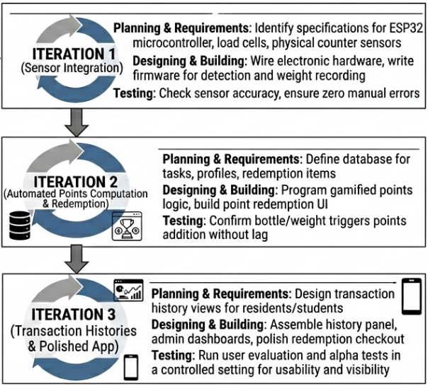
Figure 1.0 The Agile Model
The Agile model is iterative, allowing the researchers to improve the system after each testing cycle. This process helps refine Waste2Goods until it better meets user requirement
The survey respondents were chosen to evaluate the perceived need, usability, and acceptance of the proposed Waste2Goods system before its development. The responses obtained served as one of the primary bases for designing the features and functionalities of the proposed system.

4.5 Requirements Analysis

4.5.1 Functional Requirements
Functional Requirement | Description
User Registration | The system shall allow users to create an account.
User Authentication | The system shall verify users through a QR code before every recycling transaction.
Waste Submission | The system shall accept recyclable materials from registered users.
Weight Measurement | The system shall automatically measure the weight of recyclable materials using a load cell sensor.
Points Computation | The system shall automatically compute reward points based on the weight of accepted recyclable materials.
Transaction Recording | The system shall record every recycling transaction in the database.
Dashboard Monitoring | The administrator shall monitor recycling activities through a web dashboard.
Rewards Management | The administrator shall manage redeemable rewards and inventory.
Points Redemption | Users shall redeem accumulated points for available rewards.
Reports Generation | The system shall generate collection and redemption reports.
Table 1.0 Functional Requirements
This table describes the services and features that the proposed system should perform.

4.5.2 Non-Functional Requirements
Functional Requirement | Description
Performance | The system should process recycling transactions within a few seconds.
Reliability | The system should accurately record transactions with minimal errors.
Security | User accounts and transaction records should be protected through authentication.
Usability | The interfaces should be simple and easy to use.
Availability | The system should be accessible whenever an internet connection is available.
Maintainability | The software should be easy to update and maintain.
Scalability | The system should support additional users and future expansion.
Table 2.0 Non-Functional Requirements
This table describes the quality attributes of the system.

4.6 System Design

4.6.1 Conceptual Framework
INPUT
The Input component consists of the resources and information required by the proposed Waste2Goods system to perform recyclable waste collection and reward management. These include data, such as user information, recyclable material types, weight measurements, recycling tasks, reward categories, and transaction records; users, consisting of community members, students, barangay administrators, and system administrators who interact with the platform; and devices, including the ESP32 microcontroller, load cell sensor, HX711 load cell amplifier, QR code scanner, servo motor, LCD display, Wi-Fi communication module, mobile devices, and computers used to capture, process, and transmit recycling data. Internet connectivity and the Firebase cloud database are also considered essential inputs to support real-time communication and data synchronization among the system components. interaction.
PROCESS
This represents the central processing setup called the Waste2Goods: IoT-Enabled Recycling Port with Task-Based Recyclable Collection and Points-to-Goods Redemption System. It manages client-server logic and the pub-sub hybrid data streams over internet protocols.
OUTPUT
This block outlines the specific results and screen outputs generated by the system engine. It includes verified recyclable submission records, automated point allocations, updated leaderboards, and immediate reward redemption transaction receipts.
BENEFITS
Presented in the future tense to show expected outcomes from the platform deployment, this block suggests that stronger community engagement will occur. It will offer a gamified framework, support improved collection behavior, maintain recycling compliance, and create a transparent transaction ledger for the barangay.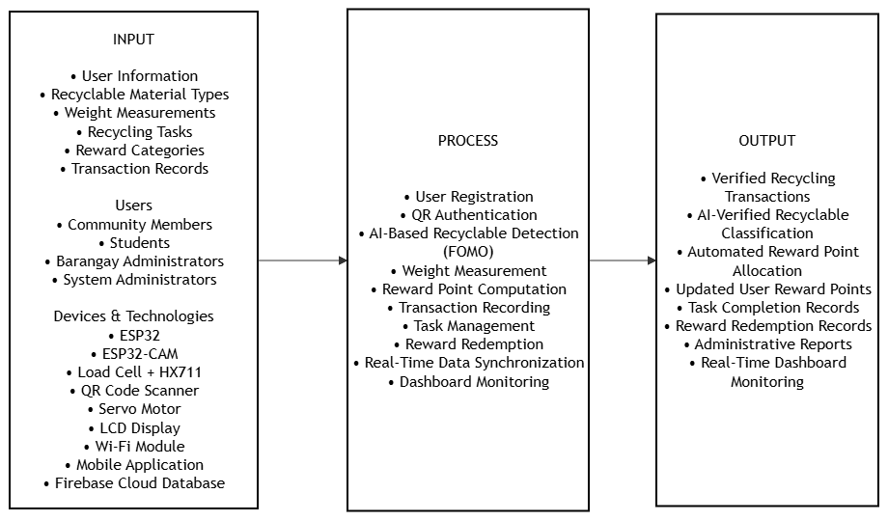
Figure 2 Conceptual Diagram Figure 2 illustrates the conceptual framework of the proposed Waste2Goods: IoT-Enabled Recycling Port with Task-Based Recyclable Collection and Points-to-Goods Redemption System using the Input-Process-Output (IPO) model. The Input consists of the required data, users, and hardware and software components. The Process describes the system's operations, including user authentication, AI-based recyclable detection using FOMO, weight measurement, reward point computation, transaction recording, and reward redemption. The Output presents the expected system-generated information, such as verified recycling transactions, automated reward points, redemption records, administrative reports, and real-time dashboard monitoring.

4.6.2 Data Flow Diagram of the Proposed System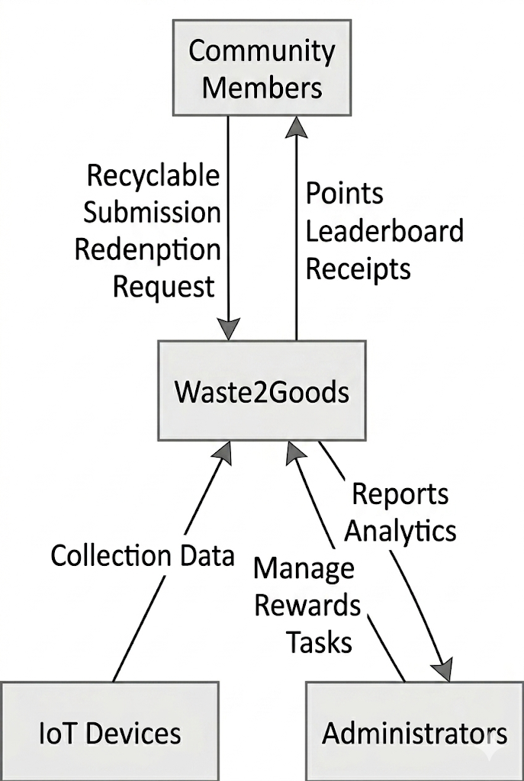Figure 3. Context Diagram of the Proposed System
Figure 3 presents the Context Diagram of the proposed Waste2Goods system. It illustrates the interaction between the external entities, including the users and administrators, and the proposed system. The diagram shows the exchange of information such as user registration, recyclable waste submissions, reward redemption requests, and administrative reports

4.6.3 Data Flow Diagram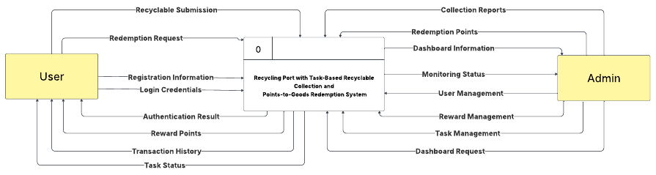Figure 4. Data Flow Diagram of the Proposed System(level 0)
Figure 4 illustrates the Level 0 Data Flow Diagram of the proposed system. It presents the major processes involved in user management, recyclable waste collection, transaction recording, reward computation, and report generation, together with the corresponding data stores and external entities.
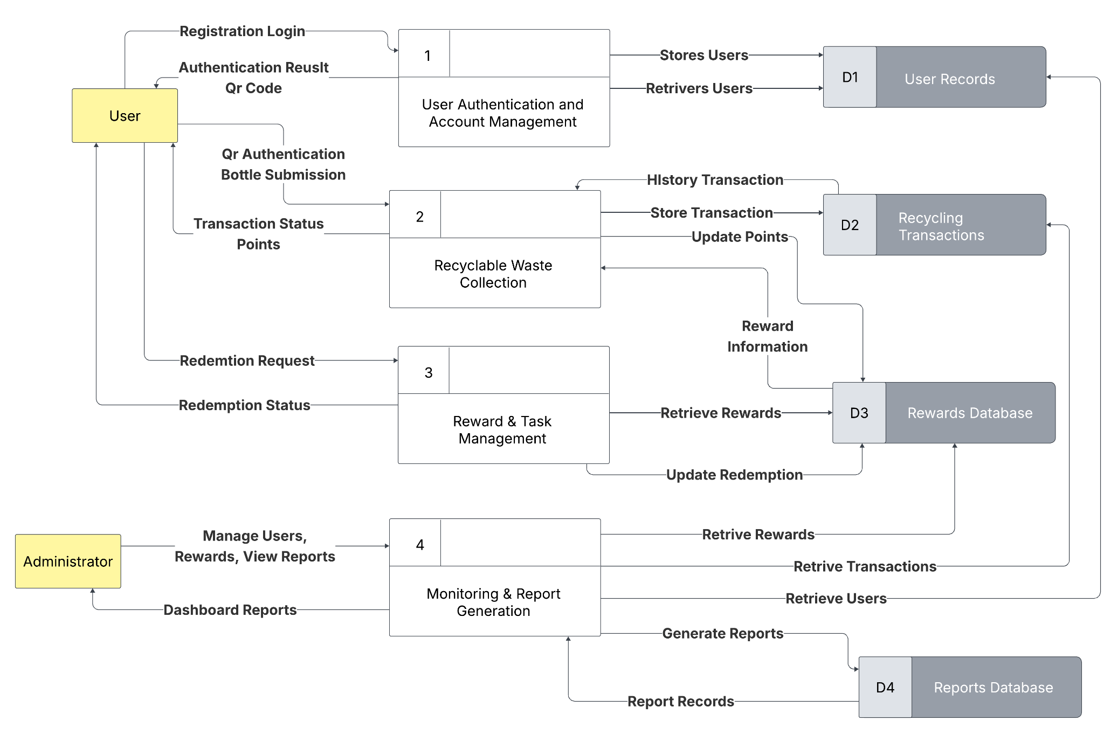Figure 5 : Flowchart of the Proposed System (Process 1 - Level 1)
Figure 5 presents the detailed process flow for recyclable waste submission. The diagram illustrates the sequence of user authentication, weight measurement, reward point computation, database updating, and confirmation of the completed recycling transaction.

4.6.5 System Architecture
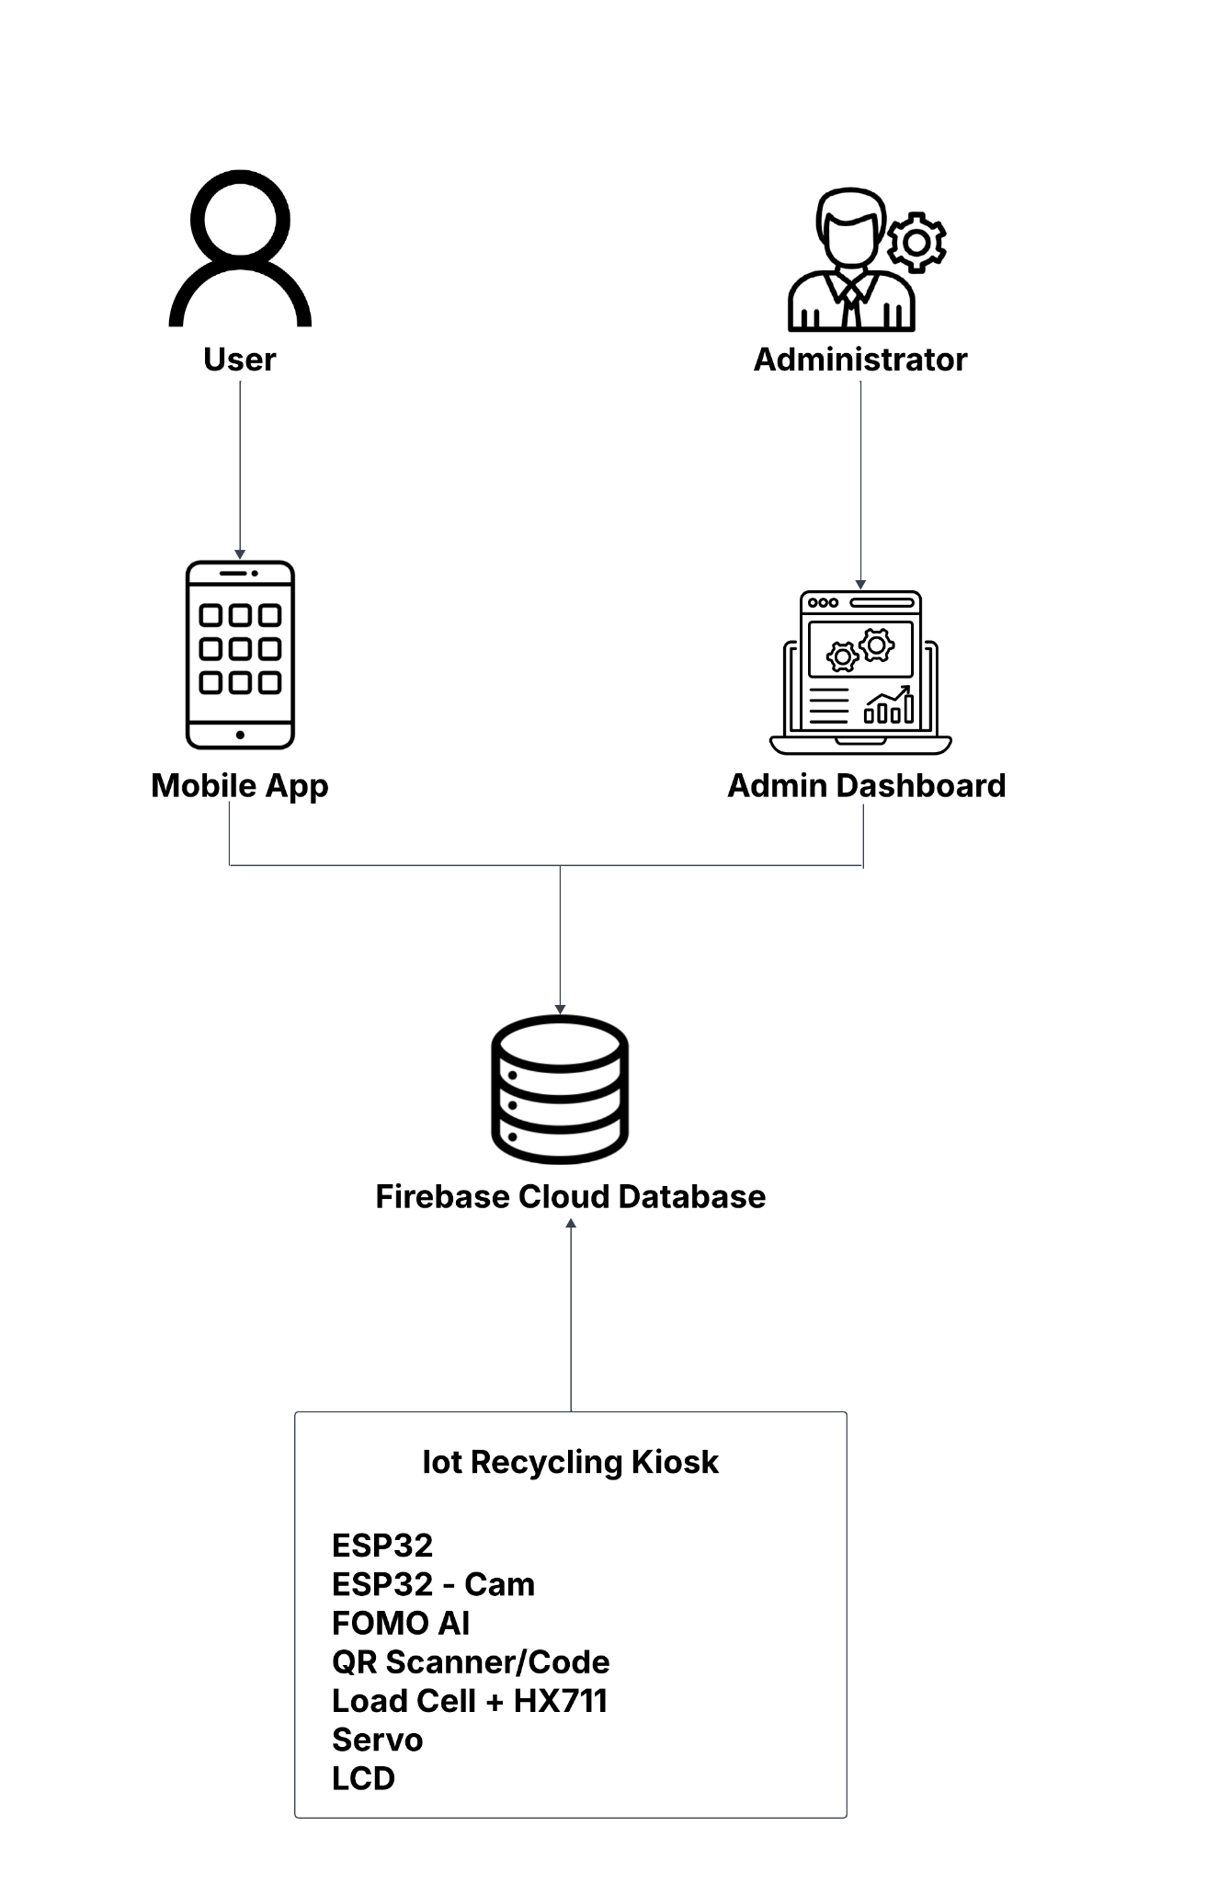
Figure 9. System architecture
The system architecture illustrates the interaction among the major components of the proposed Waste2Goods system, including the mobile application, IoT recycling kiosk, Firebase cloud database, web-based administrative dashboard, users, and administrators. Registered users access the mobile application to manage accounts, obtain QR codes, monitor reward points, and redeem incentives. During recyclable waste submission, the IoT recycling kiosk authenticates users, measures the weight of recyclable materials, computes reward points, and transmits transaction data to the Firebase cloud database through the ESP32 microcontroller. The cloud database synchronizes information in real time with the mobile application and administrative dashboard, enabling administrators to monitor recycling activities, manage rewards, and generate reports.

4.7 Development
This section presents the proposed development of the Waste2Goods: IoT-Enabled Recycling Port with Task-Based Recyclable Collection and Points-to-Goods Redemption System. The system will be developed using an agile software development approach to allow continuous refinement throughout the implementation phase.
The mobile application will be developed using Flutter to provide users with features such as account registration, QR code generation, recycling task management, transaction history, reward point monitoring, and reward redemption. Firebase will serve as the cloud-based backend for user authentication, real-time database synchronization, and storage of transaction records.
The IoT recycling kiosk will be developed using the ESP32 microcontroller integrated with an ESP32-CAM module, load cell sensor, HX711 load cell amplifier, QR code scanner, servo motor, LCD display, and Wi-Fi communication module. The ESP32-CAM will utilize the Faster Objects, More Objects (FOMO) object detection model to identify supported recyclable plastic bottles, while the load cell will measure the weight of the deposited materials. The collected data will be processed by the ESP32 and transmitted to the Firebase cloud database for real-time synchronization with the mobile application and administrative dashboard.
A web-based administrative dashboard will also be developed to manage user accounts, monitor recycling transactions, verify reward redemption requests, maintain reward inventories, and generate reports related to recyclable waste collection activities.

4.8 System Testing and Validation
The proposed Waste2Goods system will be tested and validated in a series of procedures. These activities aim at checking that hardware and software components work according to the specified functional and non-functional requirements. The testing process will also be used to find potential errors and improvements needed before the system is used for real use.
Testing will be performed with the predefined test cases to ensure the core functionalities of the system such as user registration, QR code authentication, verification of recyclable materials, weight measurement, points calculation, transaction recording, reward redemption and report generation. The results of each test shall be documented and compared to the expected results to determine if the system is functioning as expected. Validation shall be done through User Acceptance Testing (UAT) where selected students, community members and administrators will use the system in realistic scenarios and evaluate its functionality, usability, reliability and overall performance based on the ISO/IEC 25010 Software Quality Model. The feedback and recommendations of the participants will be analyzed and used to improve the system prior to deployment.

4.8.1 Testing Strategy
The proposed system will undergo several testing activities to evaluate its functionality, reliability, and overall performance.
Unit Testing will be conducted to verify the functionality of individual software modules and hardware components, including the mobile application, administrative dashboard, ESP32 microcontroller, ESP32-CAM module, load cell sensor, QR code scanner, and Firebase cloud services.
Integration Testing will be performed to ensure proper communication among the mobile application, IoT recycling kiosk, cloud database, and administrative dashboard.
System Testing will evaluate the overall performance of the complete Waste2Goods system, ensuring that all components function correctly as an integrated platform.
User Acceptance Testing (UAT) User Acceptance Testing (UAT) shall be performed after system development and internal testing are complete. The proposed Waste2Goods system shall be evaluated by selected students, community members and barangay administrators under actual or simulated operating conditions. Before testing participants shall be oriented to the features of the system and procedures to be followed. They will do predefined tasks such as user registration, QR code authentication, submission of recyclable materials, monitoring of points, rewards redemption and report generation. After finishing the tasks the participants will evaluate the system through a questionnaire, based on the ISO/IEC 25010 Software Quality Model. The collected feedback will be analyzed to decide whether the system meets the user requirements, usability issues and suggest improvement before the system is deployed for actual use.

4.9 Deployment and Monitoring Plan
Following the successful completion of system development and testings are successfully completed, the Waste2Goods system that is proposed will be implemented at the site selected for implementation. The deployment process will include installation of the IoT recycling kiosk, configuration of Firebase cloud services, deployment of the mobile application and setup of the administrative dashboard. All system components will be tested for proper communication and synchronization during deployment. System monitoring will be performed using Firebase Console to monitor server traffic, application performance, authentication logs and system errors. Firebase databases will be maintained regularly by ensuring data integrity, tracking storage use, deleting unnecessary or duplicate data, and performing backups regularly to avoid data loss. The administrative dashboard shall monitor user activity, including account logins, recycling transactions, points earned and reward redemption to identify irregular activities and to ensure proper system operation. The system reliability, security and continuous improvement will also be assured through periodic software upgrades, hardware inspections and performance evaluations.

4.10 Ethical Considerations

4.10.1 Data Privacy and Confidentiality
The proposed system collects the user information required for account registration, recycling transactions, reward points calculation and reward redemption. All personal data collected in the course of the research and system operation will be collected solely for legitimate academic and operational purposes and to the extent necessary to fulfill the objectives of the study. Confidentiality of the target respondents (students, community members, barangay officials and CENRO representatives) shall be strictly protected in the research. Personally identifiable information will not be disclosed to unauthorized individuals. Survey responses will be de-identified or coded during the data analysis to prevent identification of individual participants. The digital records such as survey responses and transaction data shall be stored in a secure cloud database with proper access control. The access to sensitive information shall be limited to the researchers and the authorized administrators only. All personal information shall be processed lawfully, fairly and transparently in accordance with the Data Privacy Act of 2012 (Republic Act No. 10173) and appropriate measures shall be implemented to ensure the confidentiality, integrity and security of such personal information during its collection, processing, storage and disposal of research data.

4.10.2 Informed Consent and Voluntary Participation
Participation in the survey and interview activity is entirely voluntary. All respondents will be provided with an informed consent form before participating which shall state the purpose of the study, the nature of their participation, the procedures, the intended use of the information collected and their rights as participants. Respondents should be allowed enough time to read the consent form, ask questions and make a decision about whether or not to participate. Only those who freely give their consent will be included in the study. Participants will be free to decline to participate or withdraw from the study at any time without penalty or disadvantage. They will also be assured that all responses will be kept strictly confidential, and that any information collected will be anonymized or coded to protect their identities. Before any data are collected, the purpose of the research, the confidentiality of the data collected, and the measures taken to protect the privacy of the participants shall be clearly disclosed.

4.10.3 Data Retention and Disposal
Research data shall be retained only for the duration necessary to complete the study and satisfy institutional documentation requirements. Upon completion of the research or after the required retention period, digital files containing survey responses and interview records shall be securely deleted from storage devices and cloud repositories. Any printed documents containing participant information shall be properly destroyed through secure disposal methods to prevent unauthorized access. The researchers shall remain accountable for ensuring the proper handling, retention, and disposal of all research-related data.

4.10.4 System Security and Vulnerability Mitigation
The proposed system shall incorporate security measures during software development to minimize potential vulnerabilities and protect the integrity of the codebase. Defensive coding practices shall be applied to reduce programming errors and safeguard the application against common software threats. User accounts shall be secured through Firebase Authentication, while administrative functions shall be restricted to authorized personnel only.
At the codebase level, security controls shall include input validation, output sanitization, proper error handling, and role-based access control. Sensitive credentials and configuration values shall not be hardcoded in the source code; instead, secure environment-based configuration shall be used whenever applicable. The system shall also utilize only verified and well-maintained libraries, frameworks, and development tools to reduce exposure to vulnerabilities and maintain software stability. In addition, the codebase shall undergo review and testing to detect and correct security weaknesses before deployment.

4.10.5 Intellectual Property and Academic Integrity
The development of the proposed Waste2Goods system shall observe academic honesty and respect for intellectual property rights. All references, software libraries, frameworks, and external resources utilized during the study shall be properly acknowledged through appropriate citation. The manuscript, source code, system documentation, and design outputs shall be developed as original academic work, with measures taken to prevent plagiarism and unauthorized use of copyrighted materials. Ownership of the developed system shall be recognized in accordance with the policies of the institution and any agreements established with the project partner.

4.10.6 Objectivity, Bias, and Fairness
The study will be objective during data collection, system design and evaluation. Survey responses and interview findings will be analysed and reported without manipulation, selective reporting or intentional bias. All research findings should be reported in an honest way, regardless of whether or not they support the expected results of the study. The survey bias must be minimized by the Research Advisor, who should also validate the questionnaire to ensure that the questions are clear and neutral and do not contain any leading language. Respondents shall complete the survey anonymously and receive the same instructions to encourage honest responses and ensure consistency in data collection. Furthermore, the proposed system shall be designed with accessibility, fairness, and usability in mind to ensure that all intended users can interact with the platform effectively regardless of their level of technical experience.

5. REFERENCES
[1] Nathanson, & A, J. (2026, June 8). Solid-waste management | Definition, Methods, Importance, & Facts. Encyclopedia Britannica. https://www.britannica.com/technology/solid-waste-management
[2] Philippine development Plan 2023-2028 Philippine developmentPlan. (2025, October 17). Philippine Development Plan. https://pdp.depdev.gov.ph/philippine-development-plan-2023-2028/
[3] Ahmed, M. M., Hassanien, E., & Hassanien, A. E. (2023). IoT-based intelligent waste management system. Neural Computing and Applications, 35(32), 23551–23579. https://doi.org/10.1007/s00521-023-08970-7
[4] Trash to cashback | Quezon City Government. (2026) Quezon City Government. https://quezoncity.gov.ph/program/qc-residents-can-exchange-trash-for-food-and-groceries-through-trash-to-cashback/
[5]Environmental Awareness: Analysis of junior High school students. (2025). ResearchGate. https://www.researchgate.net/publication/393715170_Environmental_Awareness_Analysis_of_Junior_High_School_Students
[6] Khando, K., Islam, M. S., & Gao, S. (2022). The Emerging Technologies of Digital Payments and Associated Challenges: A Systematic Literature review. Future Internet, 15(1), 21. https://doi.org/10.3390/fi15010021

[7] Agna, K., & Agna, K. (2024, August 9). Mandaluyong LGU steps up ‘trash-for-food’ program to curb flooding. Philippine Information Agency. https://pia.gov.ph/news/mandaluyong-lgu-steps-up-trash-for-food-program-to-curb-flooding/

[8] Navigating compliance challenges in modern Business: Insights and solutions - SearchInform. (2021). SearchInform.com. https://searchinform.com/articles/compliance/essentials/challenges/
[9] Farjana, M., Fahad, A. B., Alam, S. E., & Islam, M. M. (2023). An IoT- and Cloud-Based E-Waste Management System for Resource Reclamation with a Data-Driven Decision-Making Process. IoT, 4(3), 202–220. https://doi.org/10.3390/iot4030011
[10] Laha, S. R., Pattanayak, B. K., Pattnaik, S., & Kumar, S. (2023). A Smart Waste Management System framework using IoT and LORA for Green City Project. International Journal on Recent and Innovation Trends in Computing and Communication, 11(9), 342–357. https://doi.org/10.17762/ijritcc.v11i9.8370
[11] AI-ENABLED DECISION SUPPORT SYSTEMS FOR SMARTER INFRASTRUCTURE PROJECT MANAGEMENT IN PUBLIC WORKS. (2024). ResearchGate. https://www.researchgate.net/publication/393655215_AI-ENABLED_DECISION_SUPPORT_SYSTEMS_FOR_SMARTER_INFRASTRUCTURE_PROJECT_MANAGEMENT_IN_PUBLIC_WORKS
[12] Petropoulos, F., Akkermans, H., Aksin, O. Z., Ali, I., Babai, M. Z., Barbosa-Povoa, A., … Zheng, T. (2026). Operations & supply chain management: principles and practice. International Journal of Production Research, 64(1), 330–513. https://doi.org/10.1080/00207543.2025.2555531
[13] Trash to cashback | Quezon City Government. (2026) Quezon City Government. https://quezoncity.gov.ph/program/qc-residents-can-exchange-trash-for-food-and-groceries-through-trash-to-cashback/
[14] SM Supermalls. (2024). Environmental Programs on solid Waste Management - Electronic Waste Collection | SM Supermalls. https://www.smsupermalls.com/environmental-programs-on-solid-waste-management-electronic-waste-collection
[15] Sosunova and J. Porras, "IoT-Enabled Smart Waste Management Systems for Smart Cities: A Systematic Review," in IEEE Access, vol. 10, pp. 73326-73363, 2022, https://ieeexplore.ieee.org/document/9815071
[16] Jcteamjoy. (2021, May 25). QC’s plastic waste trading program extends to barangays, broadens trade options | Quezon City Government. Quezon City Government. https://quezoncity.gov.ph/qcs-plastic-waste-trading-program-extends-to-barangays-broadens-trade-options/
[17] GMA Integrated News. (2024, January 27). Mandaluyong residents swap plastic trash for food in barangay program. GMA News Online. https://www.gmanetwork.com/news/topstories/metro/898696/mandaluyong-residents-swap-plastic-trash-for-food-in-barangay-program/story/
[18] Bakar, M. A., Yusof, Y. M., Sam, S. M., Azizan, A., Ahmad, N. A., Abas, H., & Shafie, N. (2023). Garbage segregation and monitoring using Low-Cost IoT system for smart waste management. Open International Journal of Informatics, 11(1), 23–40. https://doi.org/10.11113/oiji2023.11n1.249

[19] Sosunova and J. Porras, "IoT-Enabled Smart Waste Management Systems for Smart Cities: A Systematic Review," in IEEE Access, vol. 10, pp. 73326-73363, 2022, https://ieeexplore.ieee.org/document/9815071
[20] Reverse vending machines in the circular economy: A bibliometric analysis of an underexplored enabler (2003–2023). (2023). ResearchGate. https://www.researchgate.net/publication/398164455_Reverse_vending_machines_in_the_circular_economy_A_bibliometric_analysis_of_an_underexplored_enabler_2003-2023

[21] Anuardo, R. G., Espuny, M., Costa, A. C. F., Espuny, A. L. G., Kazançoğlu, Y., Kandsamy, J., & De Oliveira, O. J. (2023). Transforming E-Waste into Opportunities: Driving Organizational Actions to Achieve Sustainable Development Goals. Sustainability, 15(19), 14150. https://doi.org/10.3390/su151914150
[22] Use of Decision-Support systems in public organizational management. (2026). ResearchGate. https://www.researchgate.net/publication/400789134_Use_of_Decision-Support_Systems_in_Public_Organizational_Management

[23] George, E. O., & George, E. O. (2024, February 8). Empirical Research: A Comprehensive guide for academics. Paperpal Blog. https://paperpal.com/blog/researcher/empirical-research-a-comprehensive-guide-for-academics
[24] ISO/IEC. (2023). ISO/IEC 25010:2023 Systems and software engineering — Systems and software Quality Requirements and Evaluation (SQuaRE) — Product quality model. International Organization for Standardization https://www.iso.org/obp/ui/en/#iso:std:iso-iec:25010:ed-2:v1:en
[25] Ma, T., & Lee, Y. (2026). Overview of quantitative research. Family Medicine, 58(2), 81–87. https://doi.org/10.22454/fammed.2026.406133

[26] Libretexts. (2021, April 29). 13.2: Qualitative interview techniques. Social Sci LibreTexts. https://socialsci.libretexts.org/Bookshelves/Social_Work_and_Human_Services/Scientific_Inquiry_in_Social_Work_(DeCarlo)/13%3A_Interviews_and_Focus_Groups/13.02%3A_Qualitative_interview_techniques

[27] Dovetail Editorial Team. (2023, February 5). Descriptive research: design, methods, examples, and FAQs. Dovetail. https://dovetail.com/research/descriptive-research/

[28] Sreekumar, D., & Sreekumar, D. (2026, March 24). What is Descriptive Research? Definition, Methods, Types, and Examples. Paperpal Blog. https://paperpal.com/blog/researcher-resources/what-is-descriptive-research-definition-methods-example

